ACTIVE ATTACK RESPONSE EQUIPMENT GRANT
TEXAS BALLISTIC SHIELD AND BREACHING TOOL

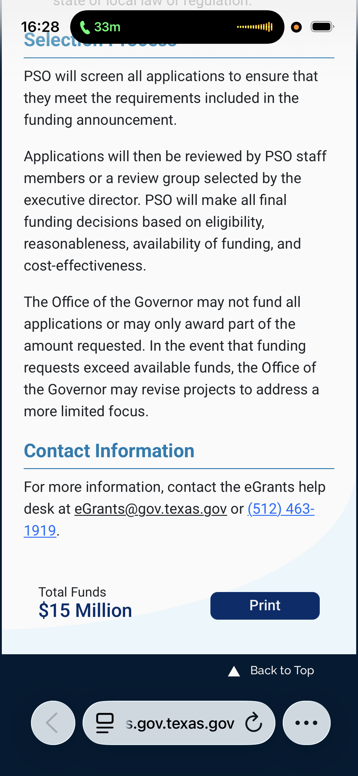
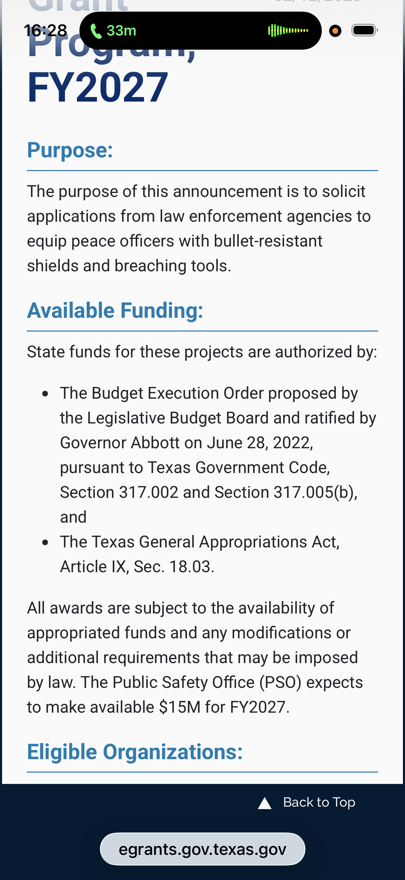
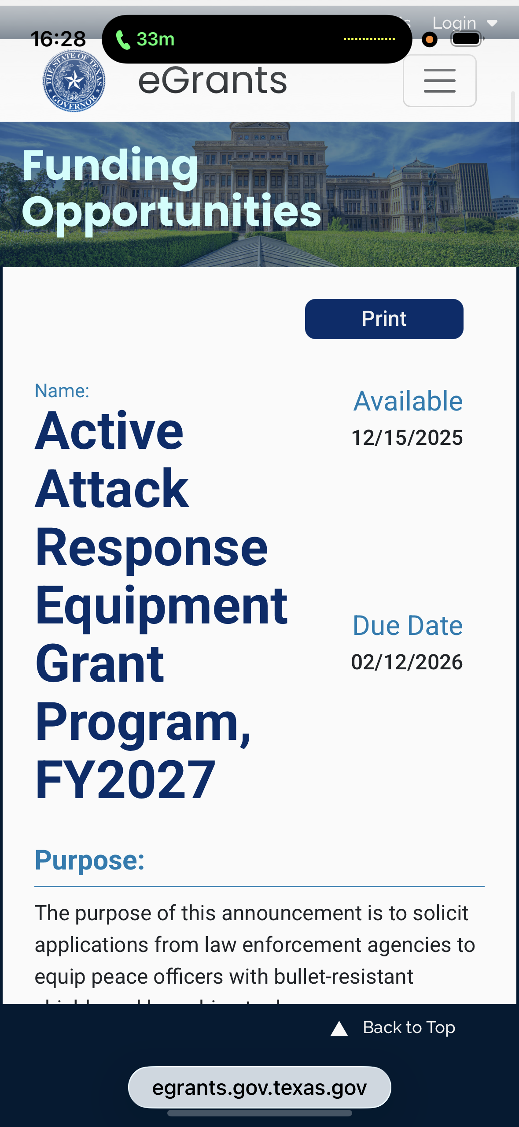

2027 Grant Ballistic Shield/ $15 Million Available
Breaching Tool

ASESS BOARD/BREACHING TOOL COMBO

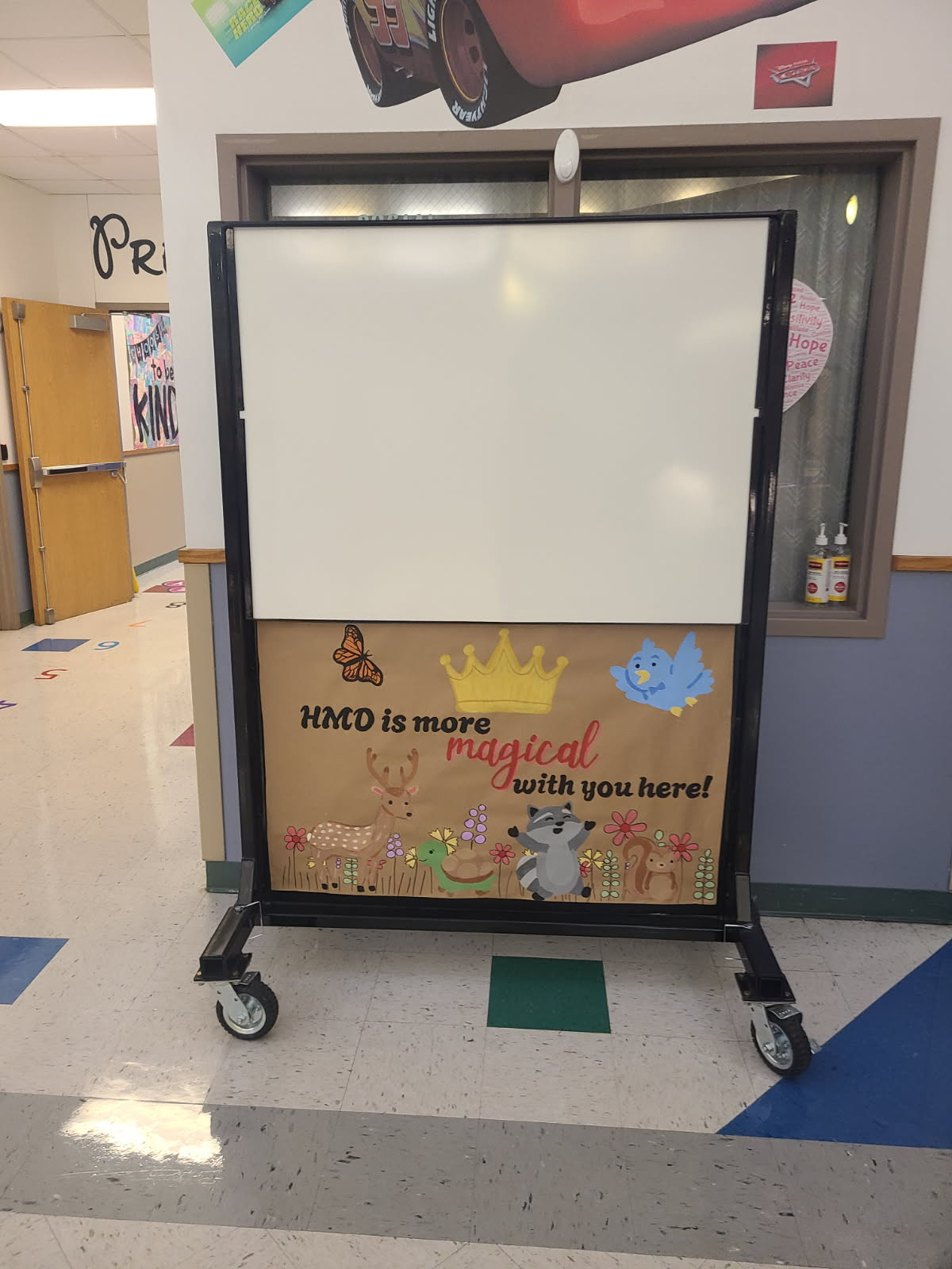
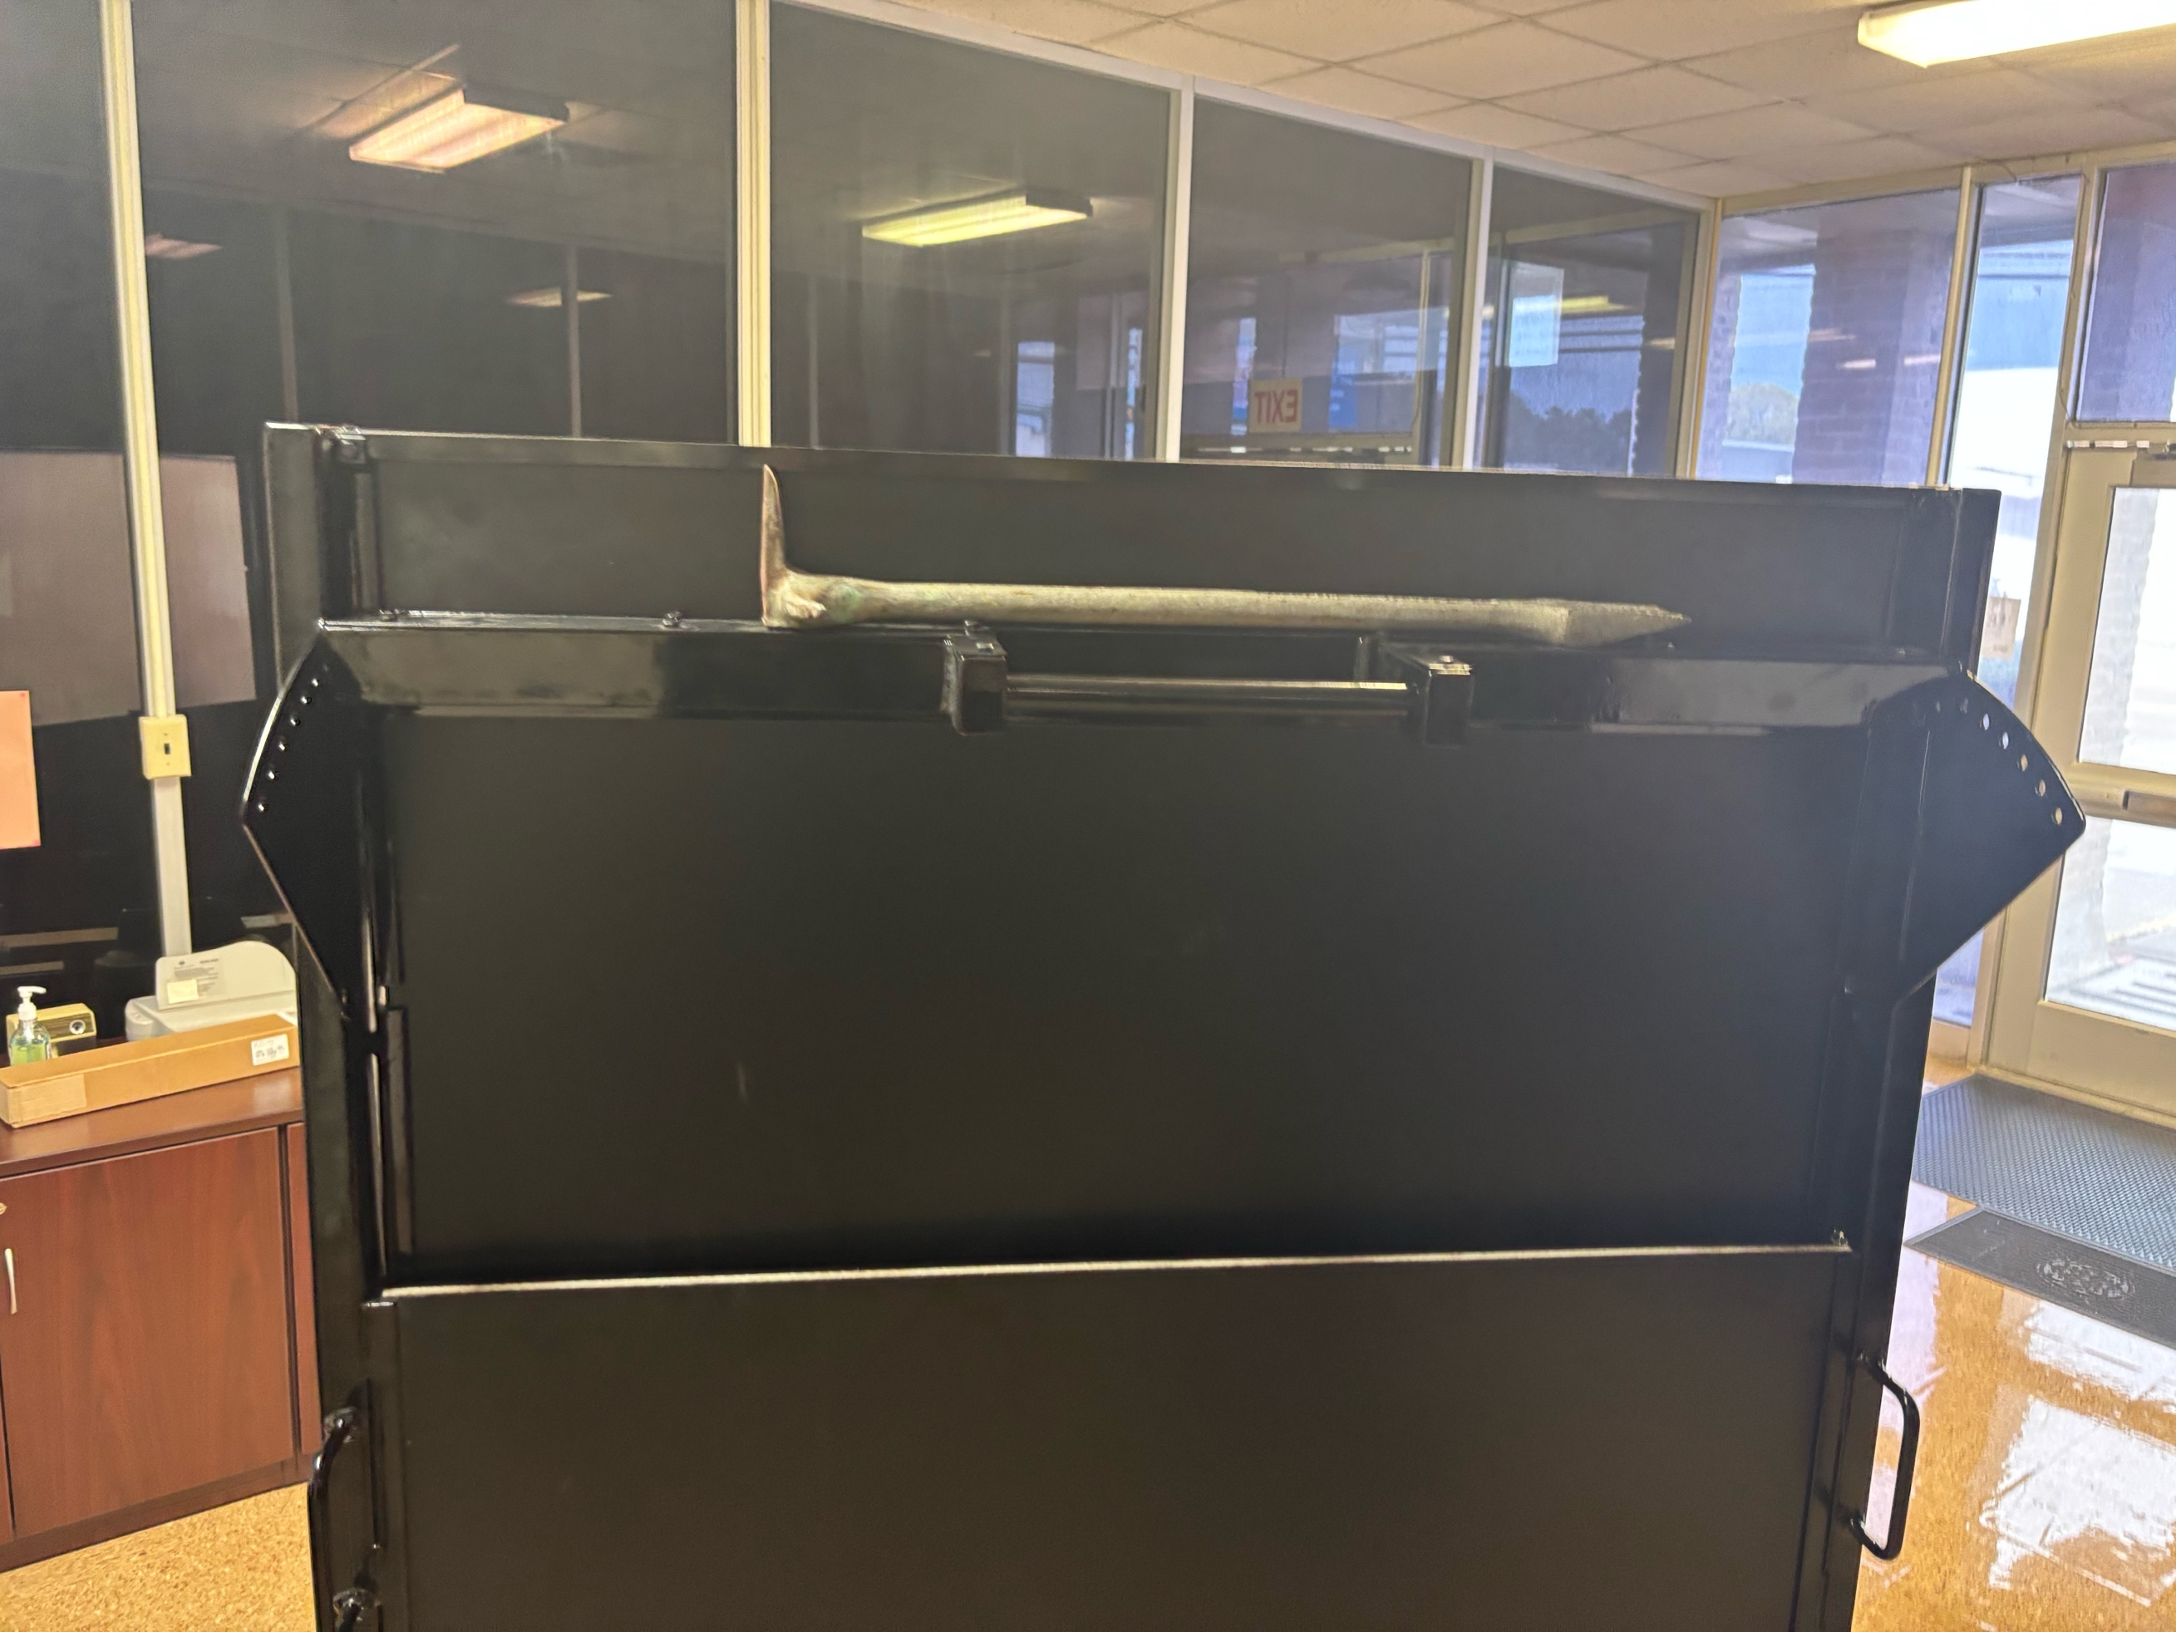
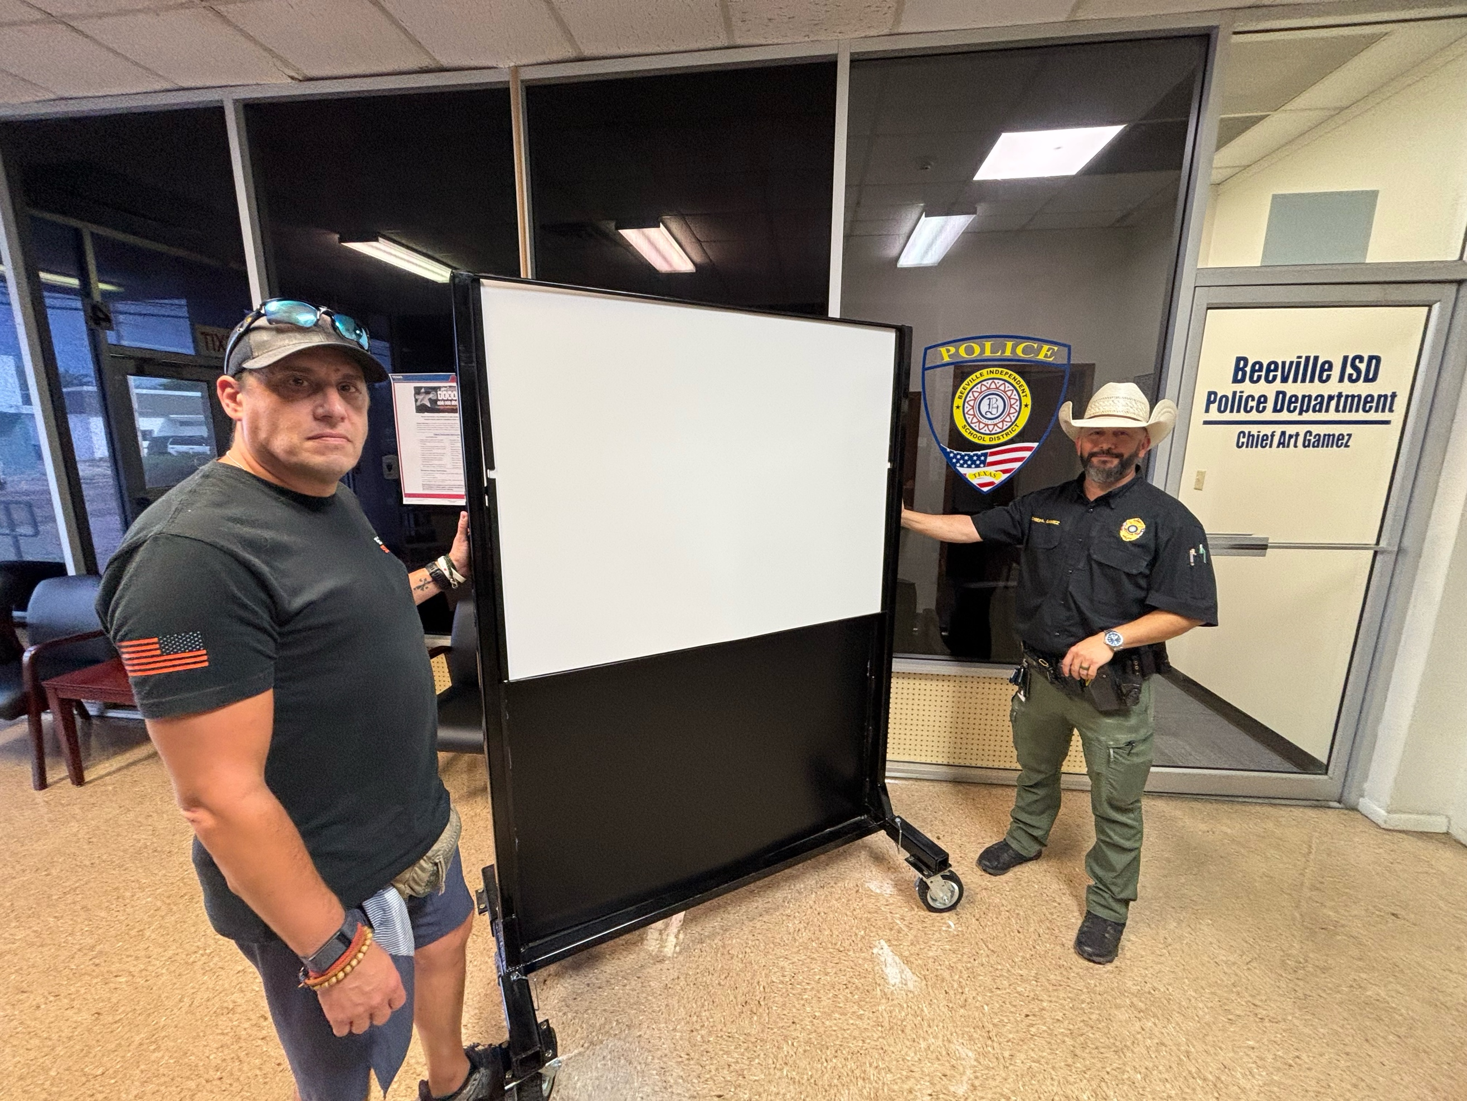

U.L./NIJ Equivalency Rated
Handgun: 9MM, .40, .45 .357
Rifle: 5.56/.223, 7.62, .308
Manufacturer: 5 rounds in 6” square. Tested over spec
Contact: Izzy@thesyndicatesecurity.com
(347)-262-5412

